Math 113 – Quiz 5

- Consider the solid with a base bounded by 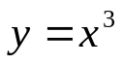, 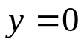, and 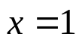 with cross sections taken perpendicular to the y-axis that form semi-circles. Calculate the volume of this solid.

- Consider the solid with a base bounded by 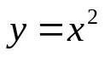 and 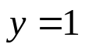 with cross sections taken perpendicular to the x-axis that form squares. Calculate the volume of this solid.

- Write the integral that will calculate the arc length of the curve 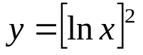on the interval 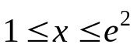.

- Write the integral that will find the area of the surface generated by revolving the curve 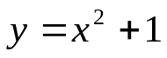 with 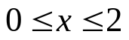about the x-axis.

- A sphere of radius r is generated by revolving the graph of 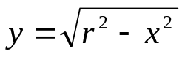about the x-axis. Verify that the surface area of the sphere is 4πr².

